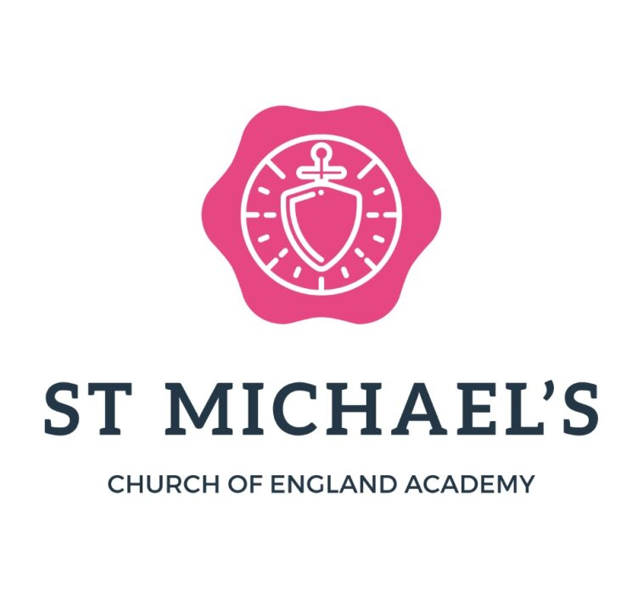
22nd January 2026
Dear Parents and Carers,
I hope this message finds you and your families well.
As many of you will remember, a year ago we introduced extended after-school provision following a government initiative. This moved our offer from one hour of after-school care to three hours, with the aim of supporting families who needed the flexibility to work longer hours.
Despite our hopes and the positive feedback from those who have used it, the overall take-up has not been as high as anticipated. Unfortunately, this means that the current model is no longer financially viable for us to continue in its present form.
However, we remain committed to providing high-quality wraparound care for our families. With this in mind, after the half-term break we will be trialling a revised approach to the provision. From that point onwards, the after-school club will run from 3.00pm to 5.00pm, offering very affordable childcare at £6 for the full two hours.
We will also be opening extended hours to our Nursery children. For Nursery families, this will sit within Nursery provision and hours, and more detailed information will be shared separately.
Our hope is that this new structure, shorter hours at a more accessible price, will encourage more families to make use of the provision, helping us to build a sustainable, well-attended after-school offer that truly meets the needs of our school community. As we grow, we want to continue supporting families as best we can, but at this moment in time we simply do not have the engagement needed to maintain the longer three-hour model.
We will keep this under regular review, and if in the future we become aware that more families require longer hours again, we will be very open to revisiting this.
Thank you, as always, for your support and understanding. If you have any questions or wish to discuss how these changes may affect your family, please do not hesitate to get in touch.
Warmest regards,
Mrs Edwards
Headteacher

