**Early Years Foundation Stage**

**Summer Term**

**What is my child learning this term?**

**Within our vision *‘’*The future we create every day’our children will develop a love of learning and be totally immersed in different worlds, cultures and times preparing them for the next stage of their education.**

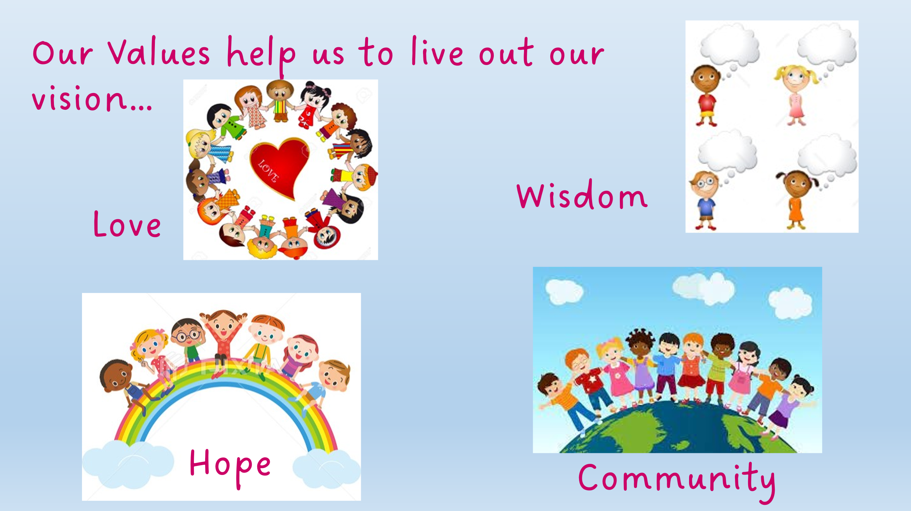

|  |  |  |
| --- | --- | --- |
| ***Summer*** | **Early Years Foundation Stage**  **Let’s Investigate...** | |
| **Curriculum Focus:** | **Let’s Investigate: The World Around Us** This term, Reception children will explore the fascinating world of plants and growth through a range of quality stories and poems. These rich texts will introduce children to key vocabulary such as "seed," "stem," "blossom," and "harvest," helping to build their understanding of the natural world. Through engaging read-aloud sessions and shared reading, children will develop their oracy skills by discussing story events, predicting outcomes, and expressing their ideas with growing confidence.Children will be encouraged to use the new vocabulary in their own spoken and written language, fostering early writing skills through activities such as labelling plant parts, writing simple captions, and creating their own nature-inspired poems. These meaningful literacy experiences will support their communication development while deepening their knowledge of how plants grow and change over time |
| **Communication and Language** | We will be developing children’s spoken language and comprehension by listening to and learning key words and phrases from a range of stories and poems. The children will have the opportunity to use this vocabulary as they act out these stories and then re-tell them, innovating to create their own narratives using the learnt story structures and language. We will be using our story sessions to give children further opportunities to develop their story-telling language, bringing these to life through shared acting sessions. Later in the term, we will learn songs and poems to perform. | |
| **Personal, Social and Emotional Development** | This summer term, we will continue to develop our Personal, Social and Emotional Development (PSED) through a range of purposeful activities and experiences. As the children prepare for transition in Year 1 - we will focus on building confidence, resilience, and independence.  Through collaborative play, circle times, and role-play, children will develop key skills such as sharing, turn-taking, and problem-solving. We will continue to encourage them to express their feelings and talk about their ideas, helping them to understand and manage emotions with increasing awareness.  This term we will also explore themes such as friendship, kindness, and caring for the environment, supporting children in developing empathy and respect for others. Positive relationships with adults and peers will be reinforced through consistent routines and clear expectations, helping children feel safe, valued, and ready for their next steps in learning. | |
| **Physical Development** | This summer term, we will be developing our physical skills through a wide range of indoor and outdoor activities designed to strengthen both fine and gross motor skills. As the weather improves, we will take full advantage of our outdoor spaces to encourage movement, coordination, and teamwork.  Children will have daily opportunities to climb, run, jump, balance, and use a variety of equipment to develop control and confidence in their movements. Fine motor skills will be supported through activities such as cutting, threading, mark-making, and using tools and materials with increasing precision.  A key highlight of the term will be our much-anticipated Sports Day! This event will give children the chance to demonstrate their physical abilities, practise key skills like running, jumping, and throwing, and most importantly, experience the joy of active participation and teamwork.  Through all these activities, we aim to promote a positive attitude towards physical activity, helping children build strength, coordination, and a sense of achievement. | |
| **Literacy** | Reading is at the heart of our curriculum and our children are read to throughout the day from high quality texts which support their understanding and vocabulary development. Each class has a ‘Favourite Five’ which are read repeatedly to the children so that they are familiar with the texts and able to re-tell these, using the language of the books confidently. Daily storytelling sessions and books to take home further encourage our children to develop a love of reading and stories. Children in Reception are taught to read through daily systematic synthetic phonics using the Read Write Inc programme and books which match the sounds they know are sent home each week. Our Nursery children are taught to identify rhymes and syllables, as well as hear and identify initial sounds. We encourage writing and mark making throughout our provision, both in adult led and independent opportunities. | |
| **Maths** | We will use stories, songs, practical equipment, and games to teach children to notice patterns, similarities and differences, and compare. We will continue to learn how to represent and compare numbers and think about the composition of numbers up to 10 and beyond. We will think about one more and one less, using a range of strategies to help us. We will learn about shapes and start to use mathematical language to describe shapes. We encourage the children to problem solve and explore mathematical concepts using manipulatives, visual representations and in real life problems. In Reception, we will begin to write numbers, learning how to form these correctly. | |
| **Understanding the World** | This term, the children will be learning about *special places*—both personal to them and important in different religions. We’ll begin by talking about places that are special to them, such as their home, bedroom, or a favourite park. This helps children reflect on what makes a place meaningful and how it makes them feel safe and happy.  We will then explore special places in Christianity and Islam, focusing on churches and mosques. Through stories, videos, photos, and simple artefacts, children will learn what these places look like, who visits them, and why they are important. They will discover key features like altars, prayer mats, stained glass windows, and minarets, and learn how people show respect and care in these sacred spaces.  This learning will support children’s understanding of different beliefs and cultures, helping to develop respect, curiosity, and tolerance. Through discussion and creative activities, children will build important vocabulary and strengthen their oracy skills by expressing their thoughts and asking questions. | |
| **Expressive Arts and Design** | This term, Reception children will be exploring the art of watercolour painting as they observe and paint flowers and plants. Using real-life examples from nature and images from storybooks, children will learn to look closely at shape, colour, and detail.  They will be introduced to watercolour techniques such as colour mixing, layering, and using different brush strokes to create texture and effect. This creative process encourages careful observation and supports the development of fine motor skills and artistic expression.  As children experiment with watercolours, they will be encouraged to talk about their choices, describe the features of their paintings, and use rich vocabulary related to plants and colour. | |
| **Characteristics of Effective Learning** | We will develop ‘Characteristics of Effective Learning’: Playing and Exploring, Active Learning and Creativity and Thinking Critically by spending time outside and in our continuous provision in class, being challenged and exposed to new ideas and experiences. Children will build on fundamental skills for life-long learning by reflecting upon the skills that they need to learn and be a part of a class and school community. | |