**Early Years Foundation Stage**

**Autumn Term**

**What is my child learning this term?**

**Within our vision *‘’*The future we create every day’our children will develop a love of learning and be totally immersed in different worlds, cultures and times preparing them for the next stage of their education.**

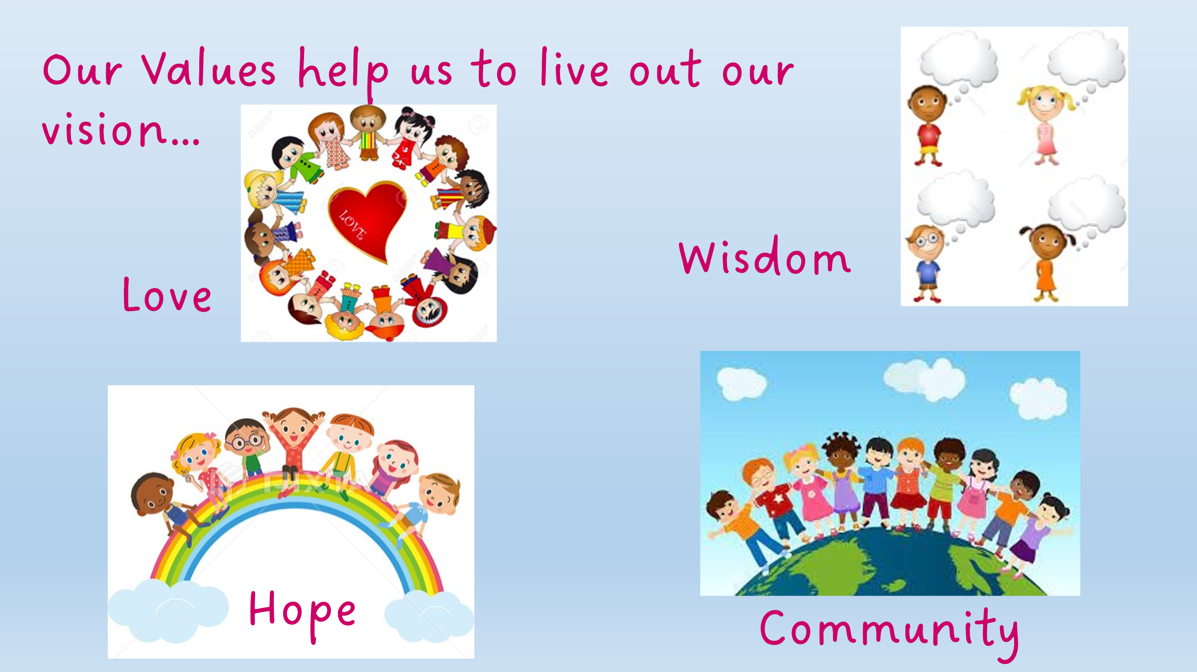

|  |  |
| --- | --- |
| ***Autumn 1*** | **Early Years Foundation Stage**  **Tell me a Story** |
| **Curriculum Focus:** | **The Story of Me!**  This half term, our learning will be centred around the big question **“Who am I?”**. The children will explore what makes them unique and special, thinking carefully about their own likes, strengths, and qualities. This will help them to begin developing a strong sense of self and celebrating what makes each of them special and unique.  We will also be learning about **similarities and differences**, recognising the many ways we are the same as our friends while also valuing the ways we are different. Through stories, discussions and play, the children will build their understanding of others and learn that every person in our class community is important.  Alongside this, we will be introducing and reflecting on our **school values of love, hope, wisdom and community**. The children will begin to understand what these mean in real life and will be encouraged to show them in their day-to-day choices – from caring for each other, sharing and helping, to working together as a team. |
| **Communication and Language** | This term, the children will be developing their confidence in sharing ideas during class and group activities. They will have lots of opportunities to talk about themselves, their families, pets, hobbies and friends, helping them to build their vocabulary, express themselves clearly and listen to others. These skills not only lay strong foundations for learning across the curriculum but also help the children to deepen their understanding of our school values of **love, hope, wisdom and community**. By listening carefully, showing respect and celebrating each other’s stories, the children will begin to understand what it means to be a thoughtful and supportive member of our class community. |
| **Personal, Social and Emotional Development** | We will use books, circle times, pictures, and games to help children name, describe and talk about their feelings. We will also be learning how to take turns, share resources, show patience, and play cooperatively. We will celebrate our similarities and differences, building children’s self-confidence and learning about our school values. |
| **Physical Development** | We will be building our gross motor control skills by climbing, balancing, and negotiating obstacles in our outdoor area, and in weekly PE lessons. We will also be building with construction materials (big and small!), painting, drawing, sticking, cutting, and mark-making to help develop fine motor skills. Regular dough-gym sessions will support children to develop their hand strength and control. Children in Reception will be taught to form letter shapes as part of their daily Read Write Inc. learning. |
| **Literacy** | Reading is at the heart of our curriculum and our children are read to throughout the day from high quality texts which support their understanding and vocabulary development. Each class has a ‘Favourite Five’ which are read repeatedly to the children so that they are familiar with the texts and able to re-tell these, using the language of the books confidently. This half term the children will share stories that build on their understanding of similarities and differences and encourage them to think more about themselves and their families. |
| **Maths** | In maths this half term, our focus will begin with learning about **3D shapes**. The children will explore and play with a range of shapes, building towers, making patterns and investigating how shapes fit together. This practical work will help them to develop early problem-solving skills, as well as an understanding of the world around them.  We will then move on to **subitising numbers 1 and 2** – learning to recognise these amounts instantly without counting. Through games, songs and practical activities, the children will begin to develop their confidence in using and applying these numbers in practical problems.  You can support this learning at home by encouraging your child to **spot 3D shapes** in the environment (such as cubes in dice, cylinders in tins or spheres in balls) and by playing simple **“how many?” games** with one or two objects. These everyday opportunities will help to build their confidence and enjoyment in early maths. |
| **Understanding the World** | This half term, we will be developing our understanding of the world by learning about the season of **Autumn** and the changes we can see all around us. We will also be exploring the **Harvest Festival**, finding out why it is celebrated and how we can show thankfulness for the food we eat. Families can support this learning by collecting Autumn treasures on walks, talking about seasonal changes, or sharing food traditions together at home. |
| **Expressive Arts and Design** | This term, the children will be exploring the work of local artist **Yvonne Coomber**, whose colourful flower paintings will inspire us to create our own artwork using Autumnal colours and expressive brushstrokes. The children will have opportunities to create and explore with a wide range of materials and share their outcomes. Together we will learn Harvest and Autumn themed poems and rhymes, using **The Poetry Basket**. |
| **Characteristics of Effective Learning** | We will develop ‘Characteristics of Effective Learning’: Playing and Exploring, Active Learning and Creativity and Thinking Critically by spending time outside and in our continuous provision in class, being challenged and exposed to new ideas and experiences. Children will build on fundamental skills for life-long learning by reflecting upon the skills that they need to learn and be a part of a class and school community. |