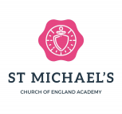

Year 1
Autumn Term 1

What is my child learning this half term?
Our curriculum is the beating heart of our school and is rooted in John 10:10
“I came that they might have life and live it to the full”

Within our vision ‘The future we create every day’ our children will develop a love of learning and be totally immersed in different worlds, cultures and times preparing them for the next stage of their education.
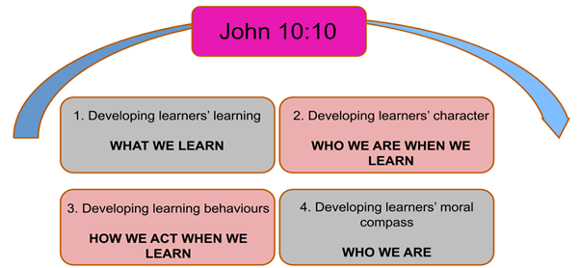

Autumn | Year 1 Curriculum
Talk for Stories | Each week we will be sharing a different story. We will dig deep into the stories and the different vocabulary used.
Writing | In Read, Write Inc this term the children will continue to learn and revise their set 1, 2 and 3 sounds. In each group, they will explore a text related to their reading levels and sounds that they are learning. They will progress into composing descriptive sentences, questions, speech and thought bubbles and short narratives both orally and written.
Maths | Our Maths focus for the first half of the term is number and Place Value. The children will be learning to count, order and compare the numbers 0-10. We will be using a variety of equipment to make numbers to understand how they are made using tens and ones. In the second half of the term the focus will be addition and subtraction within 10. We will learn to name, recognise and describe 2D and 3D shapes. We will work on place value for numbers up to 20.
Science | In science we will be identifying our body parts and investigating our senses. We will explore which body part is associated with each sense.  Throughout the year we will be exploring seasonal change. We will talk about the different seasons as they happen and the changes we observe. We will look at and discuss the weather associated with each season and how the length of the day varies.
RW | Our focus in RW for the first half term, we will be exploring the question ‘What does it mean to belong to a faith community?’ We will be talking about what groups we belong to and how we are all valuable individuals. During the second half of the term, we will be exploring the question ‘Why does Christmas matter to Christians?’ We will be recapping the events of the Christmas story and the real meaning behind why we celebrate Christmas.
Geography | In Geography, we are learning about our local area, looking at the different features of our local area. We will be learning about the different physical and human features of our locality.
History | In History we will finding out all about toys. We will talk about how the toys we play with today are different to the toys we played with when we were babies. We will look at how toys have changed over time.
PE | In P.E. this half term, we are welcoming St Southwest. They will be teaching the children a variety of activities that will look to develop their gross and fine motor skills and get them to understand the basics of working as a team. We are also lucky to be having Razzamatazz teaching us dance.
RHE | Our focus in RHE is all about families and friendships. We will look at how our behaviour affects others and about being polite and respectful. This will link to our values of Love, Community, Hope and Wisdom. The focus in in the second half of the term will be all about safe relationships. We will be looking at how we treat others and trust. We will continue to discuss how to keep safe online.
Music | In Music, we will be listening to and discussing various different pieces of music. The children will learn the song ‘Hey You!’ and learn about rhythm and pulse. We will also be working on our school Nativity.
Design Technology | In DT we will be exploring moving pictures. We will find out about levers and sliders and use these moving parts to create a moving Christmas card.
Art | Our Art topic for the first half term will focus on the seasons. The children will explore local focus artist, ‘Yuvonne Coomber’ who is known for her colourful paintings of flowers and fields. We will learn all about colour mixing, splatter art and compositions before composing their own final pieces.
Computing | We will be learning about the different parts of a computer and what the different tools can be used for. We will be drawing pictures using the different tools.

