**Early Years Foundation Stage**

**Autumn Term**

**What is my child learning this term?**

**Within our vision *‘’*The future we create every day’our children will develop a love of learning and be totally immersed in different worlds, cultures and times preparing them for the next stage of their education.**

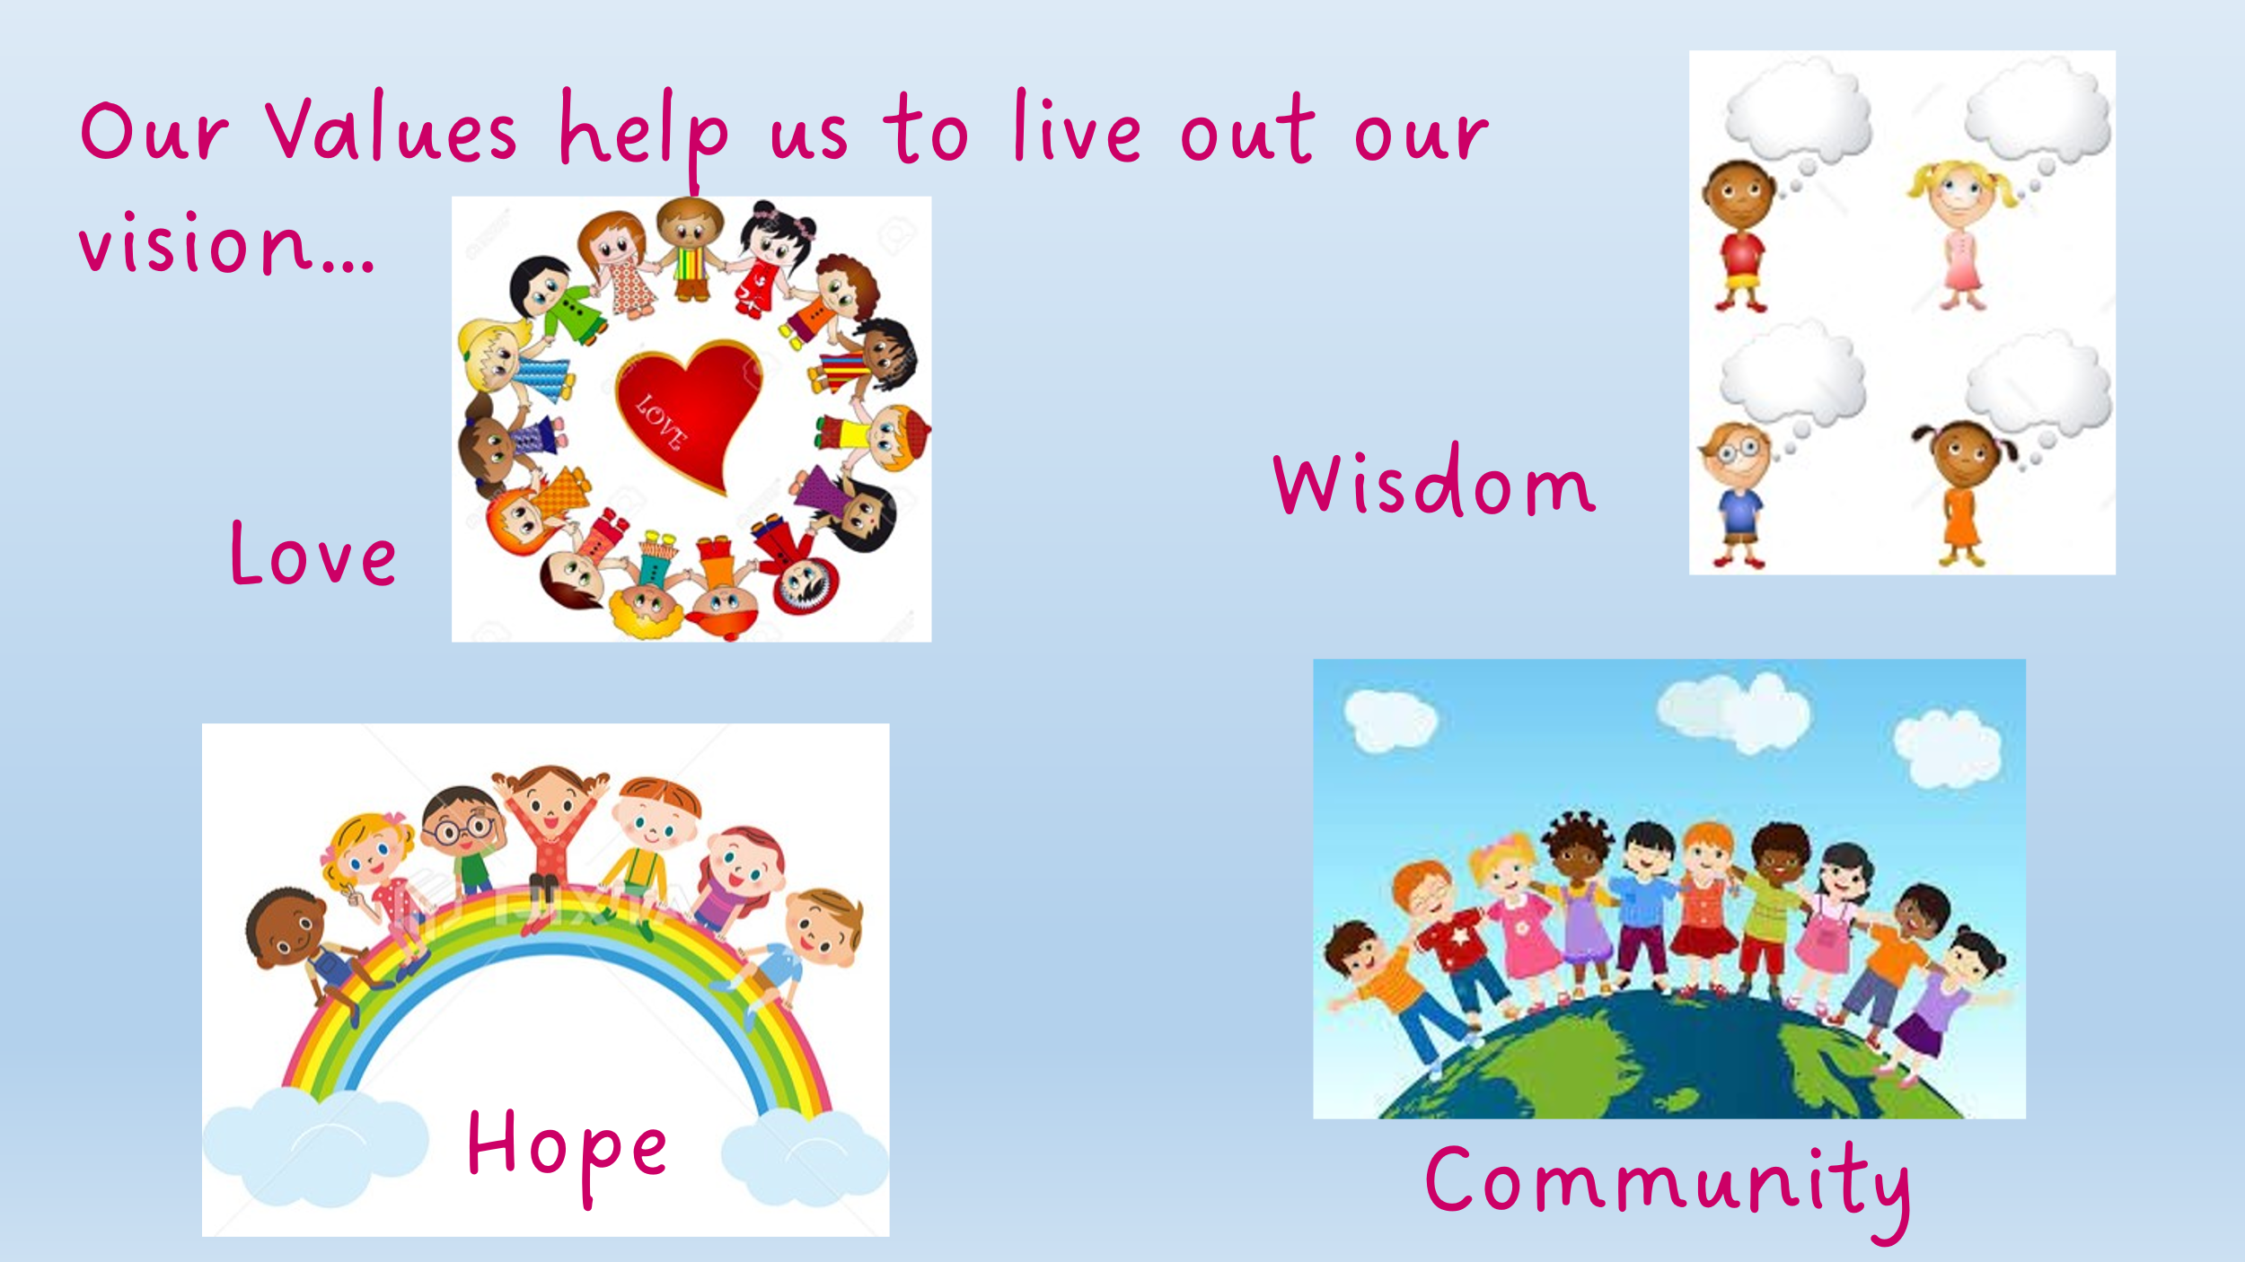

|  |  |  |
| --- | --- | --- |
| ***Autumn 2*** | **Early Years Foundation Stage**  **I wish I was a…** | |
| **Curriculum Focus:** | **Tell me a story: Traditional Tales**  This half term we will be listening to and exploring Traditional Tales, both from the UK and around the world. We will learn to sequence some familiar tales, using language from the stories and learning by heart repeated refrains and embedding new vocabulary. We will explore the characters in these stories and make comparisons between them. We will sing songs and learn poems and rhymes associated with stories and share these with our adults at home. Closer to Christmas, we will learn about the Christmas story and take part in rehearsals for a Nativity play, learning songs and poems associated with the Christmas story. We will reflect on the changing seasons and make observations of nature, listening to poems, stories and rhymes and learning new vocabulary. |
| **Communication and Language** | We will be developing children’s spoken language and comprehension by listening to and learning key words and phrases from a range of Traditional Tales. The children will have the opportunity to use this vocabulary as they act out these stories and then re-tell them, innovating to create their own narratives using the learnt story structures and language. We will be using our story sessions to give children further opportunities to develop their story-telling language, bringing these to life through shared acting sessions. Later in the term, we will learn songs and lines for our Nativity play, developing children’s confidence to perform in front of others. | |
| **Personal, Social and Emotional Development** | We will use books, circle times, pictures, and games to help children name, describe and talk about their feelings. We will also be learning how to take turns, share resources, show patience, and play cooperatively. We will celebrate our similarities and differences, building children’s self-confidence and learning about our school values. Children will join with the whole school for weekly Celebration Assemblies, celebrating their achievements and seeing these in the light of our school values and wider school community. | |
| **Physical Development** | We will be building our gross motor control skills by climbing, balancing, and negotiating obstacles in our outdoor area, and in weekly PE lessons. We will also be building with construction materials (big and small!), painting, drawing, sticking, cutting, and mark-making to help develop fine motor skills. Regular dough-gym sessions will support children to develop their hand strength and control. Children in Reception will be taught to form letter shapes as part of their daily Read Write Inc. learning. | |
| **Literacy** | Reading is at the heart of our curriculum and our children are read to throughout the day from high quality texts which support their understanding and vocabulary development. Each class has a ‘Favourite Five’ which are read repeatedly to the children so that they are familiar with the texts and able to re-tell these, using the language of the books confidently. Daily storytelling sessions and books to take home further encourage our children to develop a love of reading and stories. Children in Reception are taught to read through daily systematic synthetic phonics using the Read Write Inc programme and books which match the sounds they know are sent home each week. Our Nursery children are taught to identify rhymes and syllables, as well as hear and identify initial sounds. We encourage writing and mark making throughout our provision, both in adult led and independent opportunities. | |
| **Maths** | We will use stories, songs, practical equipment, and games to teach children to notice patterns, similarities and differences, and compare. We will continue to learn how to represent and compare numbers and think about the composition of numbers up to 5 (that 3 is a 2 and a 1, and is also 3 ones, for example). We will think about one more and one less, using a range of strategies to help us. We will learn about shapes and start to use mathematical language to describe shapes. We encourage the children to problem solve and explore mathematical concepts using manipulatives, visual representations and in real life problems. In Reception, we will begin to write numbers, learning how to form these correctly. | |
| **Understanding the World** | We will develop children’s awareness of the world around them by learning about Diwali, finding out about how it is celebrated and listening to stories and poems about the celebration of the festival. As we get closer to Christmas, we will learn the story of the Nativity and learn Christmas songs and lines to perform a Nativity play. We will create Christmas artworks and find out about how Christmas is celebrated around the world. | |
| **Expressive Arts and Design** | To ensure children have an artistic and cultural awareness which supports their imagination and creativity, children have the opportunity to create and explore with a wide range of materials and share their outcomes. We will listen to and sing songs, rhymes, stories and poems daily. Children will be taught to remember some poems and rhymes from memory using The Poetry Basket. We will listen to music and dance, exploring different rhythms and melodies and how these make us feel. We will be exploring artworks which represent Winter and Christmas, thinking about the artists’ choice of colour, texture and subject. We will create our own pieces of art and share these with each other. | |
| **Characteristics of Effective Learning** | We will develop ‘Characteristics of Effective Learning’: Playing and Exploring, Active Learning and Creativity and Thinking Critically by spending time outside and in our continuous provision in class, being challenged and exposed to new ideas and experiences. Children will build on fundamental skills for life-long learning by reflecting upon the skills that they need to learn and be a part of a class and school community. | |